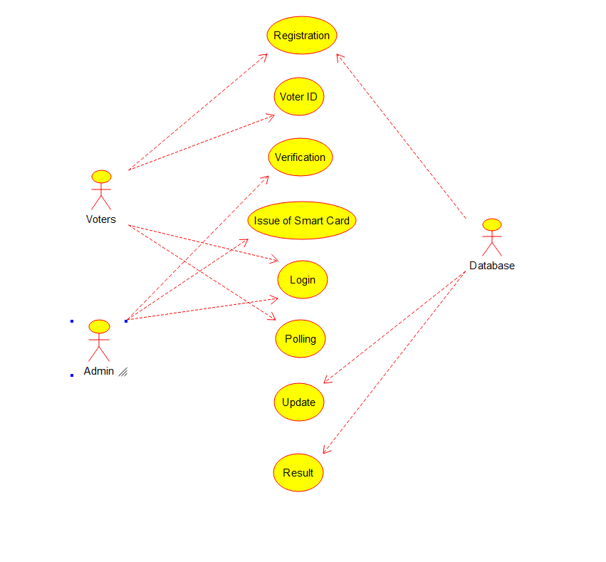

https://github.com/Sathwik284/CSA1002